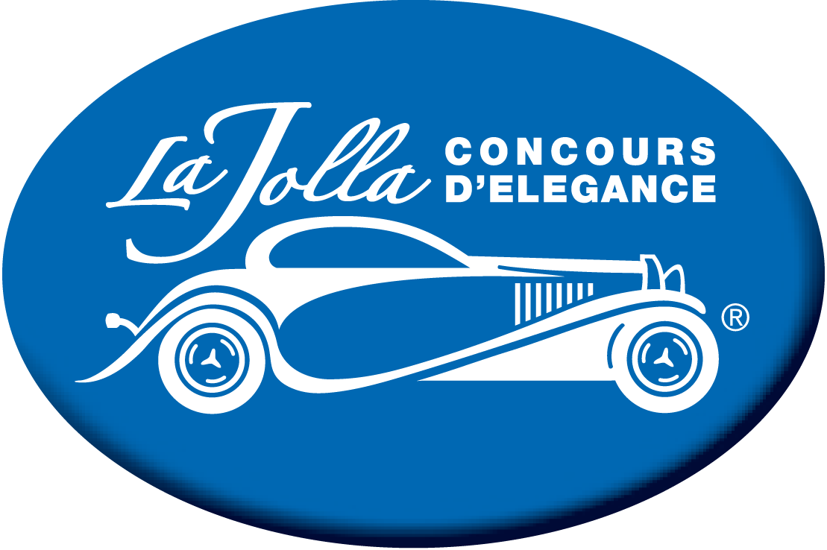

La Jolla Concours d’Elegance
Street Closure/No Park Timeline
No Park
Date: Wednesday, April 19th to Sunday April 23rd, 2023
- Coast Blvd. from the Cove to Girard Avenue for production set up
- No Park 8:00 AM Wednesday, April 19th to 10 PM Sunday, April 23rd, 2023

Street Closures
Date: Sunday, April 23, 2023
- Coast Blvd. will be closed between Prospect Street and Girard Avenue
- Girard Avenue will be closed between Coast Blvd. and Prospect Street
- The above Street Closures will be from 3:00 AM to 8:00 PM on April 23, 2023
- Ivanhoe will be closed from Prospect Street to Cave Street Sunday, April 23, 2023 from 5:00 AM to 9:00 AM

No Parks
Date: Sunday, April 23, 2023
- No-park Coast Blvd. from Prospect Street to Ocean Lane
- No park Herschel Street on the South Side between Prospect and Wall Street for ADA Parking
- The Above No Parks will be from 3:00 AM to 8:00 PM April 23, 2023
- No Park Ivanhoe from Prospect Street to Cave Street Sunday, April 23, 2023 from 5:00 AM to 9:00 AM

