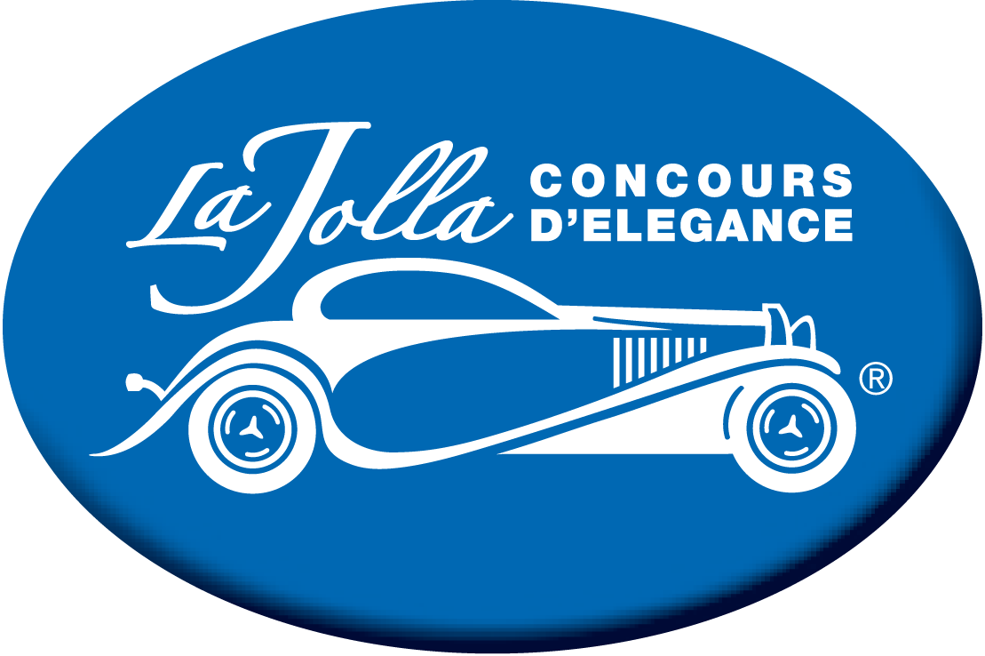

La Jolla Concours d’Elegance
Ellen Browning Scripps Park Timeline

Date: April 20th, 21st, 22nd, 23rd and 24th
- Set up will begin in the park at 6:00 AM Thursday, April 20, 2023, Friday, April 21, Saturday, April 22 and Sunday April 23
- Friday, April 21, 2023 – La Jolla Concours d’Elegance Friday VIP Party from 6:00 PM to 10:00 PM.
- Sunday, April 23, 2023 - La Jolla Concours d’Elegance from 9:00 AM to 4:00 PM
- Sunday, April 23 to Monday April 2⁴ - Breakdown from 4:00 PM to Noon on Monday April 24.

