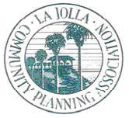

La Jolla Community Planning Association
PO Box 889, La Jolla, CA 92038 ♦ http://www.LaJollaCPA.org ♦ info@LaJollaCPA.org
August 25, 2022

Hon. Joe LaCava
Council District 1
202 "C" Street, 10th Floor
San Diego, CA 92101
Phone: 619-236-6611
Email: joelacava@sandiego.gov

Dear Councilmember LaCava,

The La Jolla Community Planning Association, La Jolla Parks and Beaches, Inc., La Jolla Shores Association and Bird Rock Community Council respectfully submit our joint list of city budget requests for the 2023-2024 Fiscal Year. Included in the list are Capital Improvement Projects, Maintenance Projects and Technical Studies that are prioritized by category.

We ask that these items be seriously considered during upcoming budget discussions and stand ready to assist if you have questions or require additional information.

Sincerely,

Diane Kane, President Janie Emerson, President
La Jolla Community Planning Association La Jolla Shores Association

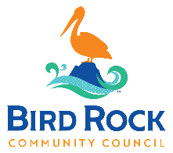
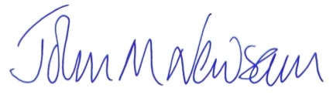

Bob Evans, President John M Newsam, President
La Jolla Parks & Beaches, Inc. Bird Rock Community Council

Cc: Mayor Todd Gloria & Councilmembers

