February report
City Makes Additional Shelter Available for Inclement Weather
- The City's HSSD, SDHC, RTFH, Alpha Project, Father Joe's Villages, PATH, San Diego Rescue Mission, and other organizations have worked to expand daily shelter options.
- During COVID-19, there has been reduced capacities to prevent spread of the virus. The City continues to work with the County and other organizations to provide safe practices for virus prevention.
- These groups have worked together to result in the addition of 65 beds to be activated during inclement weather —55 beds at Father Joe’s Villages’ Paul Mirable Center and 10 beds operated by the San Diego Rescue Mission. Additional sites are still under evaluation by the City, RTFH and SDHC for even greater capacity.
Mayor Gloria One Year in Office – State of the City Address
- December 10th, marked Mayor Gloria’s one year anniversary of taking office this administration strides in addressing the biggest issues of our time, some of the highlights include:
  - Led San Diego though Covid-19 pandemic and recovery
  - Comprehensively addressing homelessness
  - Keeping residents in their homes
  - Building more housing
  - Leading on Climate Action
  - Reimagining policing and preserving public safety
  - Creating a welcoming city
  - Getting City Hall back on track
  - Investing in infrastructure
  - Making San Diego more equitable
  - Diversifying city leadership
- To learn more please visit our press release that has a comprehensive list of accomplishments on a PDF.
- Please view Mayor Gloria’s State of City Address here https://www.sandiego.gov/mayor/2022-state-of-the-city-address
Update on Sexy Streets
- In August, the City Council approved $40 million for street repair as part of Mayor Gloria’s “Sexy Streets” initiative to improve the condition of your local roads, this initiative which will allow us to pave roughly 54 miles of road for San Diegans over the next 2 years.
- We've released the project list for the next two fiscal years. This list was developed with input from the City Councilmember from each district and scoring from the Climate Equity Index to ensure that public tax dollars have the highest return on investment.
- District 1 roads:
  - La Jolla Parkway from Hidden Valley Rd to State Route 52
  - La Jolla Parkway Off Ramp from La Jolla Parkway to La Jolla Scenic S. Dr.
  - La Jolla Parkway On Ramp from La Jolla Scenic N. Dr. to La Jolla Parkway Off Ramp
  - Paseo Bonita from Rutgers to End
  - Clemson Circle from Rutgers to End
Homes For All of Us Housing Package Update
- On July 2021, Mayor Gloria announced his “Homes For All of Us” housing initiative which features two Housing Action Packages each consisting of a suite of amendments to City development regulations and property use that streamline housing production.
- Mayor Gloria has set forth to move forward with the first of two Housing Action Packages
- The items below that are part of the Housing Action Package that went under consideration on December 16th which received unanimous approval from the Planning Commission:
  - Housing at City facilities: Streamlines the process for building affordable and middle-income homes on city-owned sites.
  - Affordable housing in all communities: Encourages affordable housing construction in communities with little to no affordable housing. To meet the city’s climate and equity goals, the homes must be built near transit and in “high resource” areas — areas close to good-paying jobs that have low levels of air and water pollution and a high student achievement.
  - Employee Housing Incentive Program: Provides incentives for non-residential developments to build homes or pay into a San Diego Housing Commission fund used to develop affordable homes.
  - Live/work flexibility: Currently, the City allows for the development of live/work units that function as both a home and place of business. This proposal would further ease requirements for live/work units to allow for more work-from-home and telework opportunities.
  - Housing Accessibility Program: Provides incentives to housing developments that include more accessible housing, including housing for seniors and people who have disabilities.
  - Housing for families: Provides incentives for multifamily housing developments to build homes with three or more bedrooms to ensure that families of all sizes have opportunities for housing. Additional incentives are awarded if the three-or-more-bedroom units are reserved for middle-income families.
- Here is the timeline:
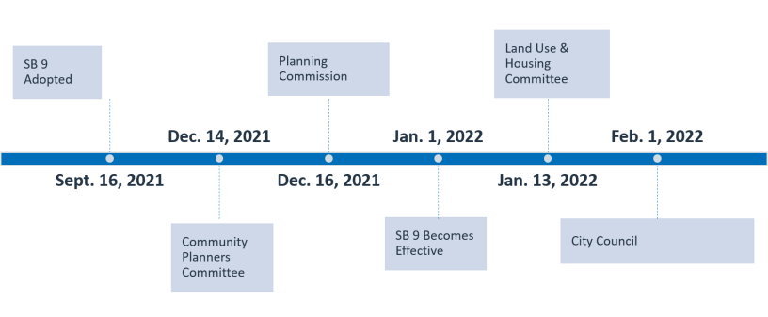

- The “Homes For All of Us” initiative also includes Blueprint SD, which is a new approach for the City of San Diego’s community planning process that will align with climate and housing goals, as well as the formation of the Middle-Income Housing Working Group.
- The City Council is expected to consider the first Housing Action Package early in 2022. After that, a second Housing Action Package will be prepared to potentially include additional statewide measures, recommendations from the Middle-Income Housing Working Group, and additional amendments to the City’s Land Development Code related to the production of more housing.

Minimum Wage 15$ Per Hour
- When Mayor Gloria was a Councilmember, he authored the City’s Earned Sick Leave and Minimum Wage Ordinance, which originally set the path toward $15-per-hour which became effective this year on Jan 1st 2022.
- The minimum wage increase is applicable to all industries and businesses, with no exceptions, and tips and gratuities do not count toward payment of minimum wage. Updated notices are available on the City’s Minimum Wage Program website and must be posted in a conspicuous place at any workplace or job site.
Covid-19 Updates:
- In the first week of December, it was reported that the first confirmed case of the Omicron coronavirus variant has been identified in California. The World Health Organization has classified the new variant as a "Variant of Concern" and the CDC is actively monitoring its transmission.
- The best way to protect yourself and others is to get vaccinated against COVID-19. Vaccines are safe, free, and effective. You can make an appointment to get the COVID-19 vaccine here.
- Booster shots are available, and encouraged, for those who have completed their primary COVID-19 Pfizer-BioNTech and Moderna vaccinations at least six months ago and Johnson & Johnson at least 2 months ago.

